Mast bhai 👌 Ab aate hain **Third-Party Modules ke 2 exercise** par. Ye tumhe npm ka use aur VS Code me practice dono karayenge. Chalo step by step dekhte hain:

**📝 Exercise 1: Colorful Console Logger (chalk module)**

👉 Tumhe ek program banana hai jo **chalk** module ka use karke alag-alag colors me console output dikhaye.

**Step 1: Install**

npm init -y

npm install chalk@4

**Step 2: app.js**

const chalk = require('chalk');

console.log(chalk.blue("Hello Bhai! Ye blue color me hai"));

console.log(chalk.green("Node.js seekhna mast hai 😎"));

console.log(chalk.red.bold("Error aaya re bhai!"));

console.log(chalk.yellow.bgBlack("Warning: File missing!"));

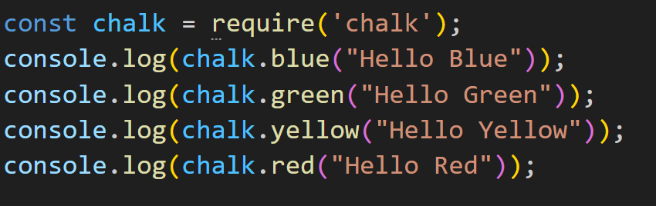

👉 Run: node app.js  
Tumhe terminal me alag-alag colors me output milega.

**📝 Exercise 2: Random Joke Generator (npm joke module)**

Bhai 👌 error ka matlab simple hai:

👉 **Cannot find module 'one-liner-joke'** = Tumne one-liner-joke package install hi nahi kiya ya galat jagah install ho gaya.

**✅ Solution Step by Step (Desi Style)**

1. **Pakka karo ki tum project folder me ho**  
   Jaise tumhare case me:
2. I:\Mastery Core Concept\Day22
3. **npm init kar lo agar pehle nahi kiya**
4. npm init -y
5. **Ab package install karo**
6. npm install one-liner-joke

Ye tumhare project ke andar node_modules folder banayega jisme one-liner-joke ka maal aa jayega.

1. **server.js code likho**

const jokes = require('one-liner-joke');

const getRandomJoke = jokes.getRandomJoke();

console.log("Bhai tere liye ek joke:");

console.log(getRandomJoke.body);

**Run karo**

node server.js

Tumhe ek random joke print hoga har run pe 😂

⚠️ **Common Galtiyan jo ye error deti hain:**

* Galat folder me npm install kar diya
* node_modules folder delete ho gaya ya copy nahi hua
* Package ka naam galat likh diya

👉 Bhai agar tum chaho to main tumhe ek **backup exercise** bhi de sakta hoon one-liner-joke ke bina — jaise **npm ka “jokes” ya “dadjokes” package** — jisse tum alag jokes try kar pao.

Kya main wo bhi bataun?

**🎯 Desi Summary**

* **Exercise 1** → Chalk se console colorful banao
* **Exercise 2** → one-liner-joke se masti wale jokes print karo

Bhai, chaahe to main tumhare liye ek **bonus exercise** bhi bana sakta hoon jisme hum express ka use karke ek **mini server** banayenge jo browser me joke ya message show karega. Kya banaun?